
Speen C of E School
Monday Newsletter - 11 May 2026

Star children from last week:

w/c 27 April w/c 04 May
KS1: Whole Class – School trip Rebecca
Class 2: All Year 2 – Football excellence!
Year R: Thomas Whole Class!
Manners trophy: Chiara
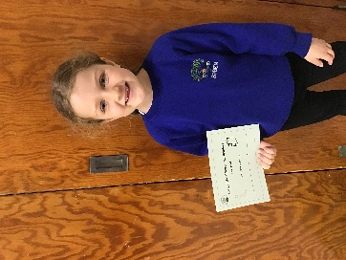
Super Star Reader – Silver Ava
Top doodlers: Aria Arthur Rayyan
Top Doodling class: Year 1

You will see above that we have included two weeks of Star children in this newsletter – we did not want those children to miss out on their mention as we did not send out a newsletter last week!

Well done to all children!

Housekeeping:
KS1 Rotary Art Competition: The children recently entered this competition and we were very excited to learn that quite a few of our children were mentioned. A poster is attached to our email which gives details of the Art Exhibition on the 23rd May 2026. All welcome to visit the Exhibition.

Picture News: Please see the link to the Picture News Takehome:
https://www.speenschool.com/attachments/download.asp?file=271&type=pdf
This explains what our Thursday Picture News assembly is about and gives you ideas for discussions at home.

From the Children
A big thankyou to the New Mozart Orchestra for coming in to school and playing for us. Year 1 and Year 2 also had a violin lesson!
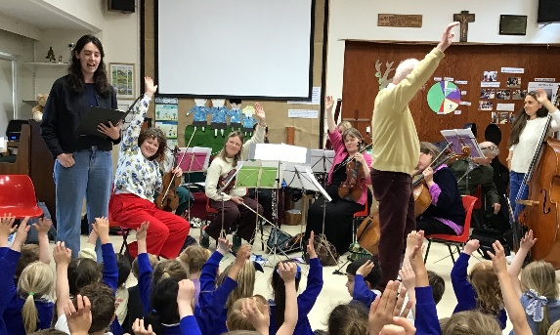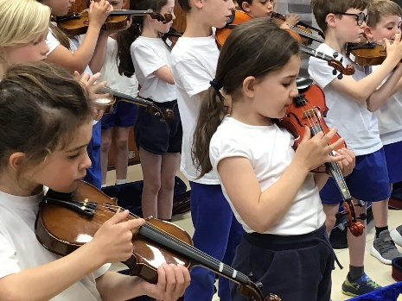

School Council
We are working on our 2026 Travel Plan Award. This morning we talked to the whole school about public transport and how it helps make roads safer. We asked the children to let us know how many times they use public transport over the half term holiday. We will give everyone a chart they can fill in every time they use a train, bus, tube, tram or ferry.

Weekly learning

Tapestry – Reception Class / Little Apples
Dojo – KS1
Please continue to use these programmes as a form of communication but remember that Mrs Bird teaches on Mondays & Tuesdays and Ms Vincze on Wednesdays/Thursdays and Fridays. Don’t forget to add comments or ‘likes’ from time to time so that staff know you have seen what has been added under your child’s profile. At the end of each year, parents / carers receive a link where they can download the entire journal from the year.
At the end of each week we are uploading information to the School Website for the following week’s learning and subsequent homework activities. We have included links to these pages to make it easy to access for you:
https://www.speenschool.com/bramley-class
https://www.speenschool.com/pippins-class

After School KS1 Clubs:
Mondays – Dance Club
Tuesdays - French Club

Diary Dates:
(for Diary dates set for this academic year, please see the calendar link)
https://www.speenschool.com/calendar/?calid=1&pid=5&viewid=1

This is the space where weekly activities are mentioned that are extra to the daily curriculum. Please remember to read and add to your diary, however these dates are not set in stone as they sometimes get changed for reasons beyond our control, so it is very important that you read this reminder letter very carefully and make a note of any dates / date changes.

Wednesday 14 May: Circus Skills Workshop
Friday 15 May: 08:30am Final Dance Friday

PTA NEWS
May
Frozen Fridays After school – Every Friday May & June – School
We are pleased to let you know that Frozen Friday will be starting up again from Friday 8th May!
Every Friday (except 12th & 19th June), children will be able to enjoy an ice lolly after school for £1, with all proceeds going towards PTA fundraising and future school activities. Frozen Friday will take place under the hut at pick-up time. Please ensure children are supervised while enjoying their ice lollies.
June
Sports Day – Tuesday 9th June – From 12.45pm – School
We are looking forward to our upcoming Sports Day, and we’re excited to let you know that the PTA will be running a BBQ, drinks stall, and fun activities for families to enjoy after Sports Day events.
There will be a selection of hot food, refreshments, and games available, with all proceeds going towards PTA fundraising to support future school events and resources.
In order to make this event a success, we need your support and require 6 x volunteers to help with this event. If you are happy to help , please message one of the PTA. Many thanks.

Mental Health First Aider:
We now have a trained member of staff in this qualification. Should you feel the need for any support please do not hesitate to get in touch via the School office. All enquiries will be treated confidentially. This note will stay in Monday Reminders weekly.

We hope you find this Monday Newsletter email useful, and if you need to know anything at all or would like clarification about the above, please do not hesitate to contact me. I work in the office every day: Monday/Fridays – an earlier finish of 1:30pm but the rest of the week is a 3:00pm finish. If you have emailed something that is urgent for the same day, and I have not replied, please give the school office a ring 01494 488321, Mrs Robyn Moore.

