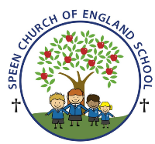Curriculum Overview- Pippins class Spring Term 2026
Week beginning- Monday 9th March ….
Below is some of this week’s learning and highlights…
Literacy
Revision of the Phase 3 GPC’s
Focus on –Oral blending - games and word building/decoding
Tricky words – no of to into she he we
Reading decodable short sentences. (We will be writing short phrases modelled and then written independently.)
Reading longer words using the chunking method- ask the children if you are not sure!
Mathematics – Time/ Building 9 & 10
The children will be extending the skills of finding ‘1 more’ with numbers to 10 to finding ‘1 less’
with numbers to 10. They will explore number bonds to 10 using real objects in different contexts
and build 10 using two parts.
Spring Term 2 Topic ‘Starry Night’
The Sun
PSHE /RE
The children will explore what celebrations take place in a church and learn about Christenings
CREATIVE ART & DESIGN
Art work based on the story of ‘How to catch a star’
MUSIC
GYM

Theme : Jack and the Beanstalk

The children will develop jumping and landing safely from a height

