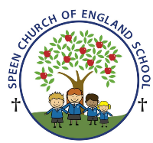Curriculum Overview- Pippins class Spring Term 2026
Week beginning- Monday 18th May ….
Below is some of this week’s learning and highlights…
Literacy- we will continue with
Revision of the GPC’s – ai igh ee oa ow oi ear air er
Focus on –Oral blending - games and word building/decoding
Tricky words – (to into they all are one) out today
Reading decodable short sentences. We will be writing short phrases modelled and then written independently.
Reading longer words using the chunking method.
Suffixes- est -ing ed/t ed/id Little Wandle Assessment time
Mathematics
We will be exploring the properties of shapes and spatial relations. The children will use their previous knowledge of positional language and now progress to explaining more complex shape arrangements.
Summer Term Topic ‘Sunshine and flowers’
Fruit salad !!! to help children understand that a lot of the food we eat is grown and comes from plants.
PSHE /RE
I can wash my hands thoroughly and understand why this is important especially before I eat and after I go to the toilet.
CREATIVE ART & DESIGN
Fruit salad this week
MUSIC- Musical Sticks
To recognize musical patterns and compose simple musical patterns, exploring duration and pitch To follow notation
GAMES Ball Skills: Unit 2
Rainy Days
LO: To develop throwing and catching with a partner

