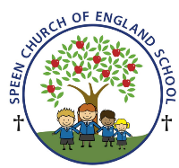Curriculum Overview- Pippins class Summer Term 2026
Week beginning- Monday 5th May ….
Below is some of this week’s learning and highlights…
Literacy- we will continue with
Revision of the GPC’s – ai igh ee oa ow oi ear air er
Focus on –Oral blending - games and word building/decoding
Tricky words – (we he she me be says) there when what one
Reading decodable short sentences. We will be writing short phrases modelled and then written independently.
Reading longer words using the chunking method.
Mathematics
We will develop experiences of building the numbers from 14 to 20 and practice counting verbally beyond 20, noticing the counting patterns involved. The children will build on understanding and exploring the change structure of addition (augmentation) by adding more. The focus for this is on increasing a quantity by a given amount, while continuing to work within 10
Summer Term 2 Topic ‘Sunshine and flowers’
Lots of planting this week again and some work on Recycling and reusing.
PSHE /RE
I know which foods are healthy and not so healthy and can make healthy eating choices
CREATIVE ART & DESIGN
Printing
MUSIC – Theme- Snail Trails
The children will be asked to recognize high and low sounds. To compose and play simple pitch patterns using tuned percussion and to follow a simple musical score.
GAMES (no games this week as Bank Holiday)

