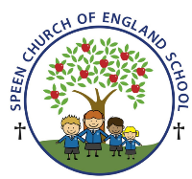Curriculum Overview- Pippins class Spring Term 2026
Week beginning- Monday 23rd March ….
Below is some of this week’s learning and highlights… we will have a shorter timetable this week as it is the last week of term
Literacy
Revision of the Phase 3 GPC’s
Focus on – z/-s s/-s iz/-es
Oral blending - games and word building/decoding
Tricky words – they all by my are sure pure
Reading decodable short sentences. (We will be writing short phrases modelled and then written independently.)
Reading longer words using the chunking method,
Mathematics
The children will be working on the concept of even and odd numbers.
Spring Term 2 Topic ‘Starry Night’
We will learn about the different planets in our Solar System
PSHE /RE
To know why Christians celebrate Easter and relate it to our own celebrations
CREATIVE ART & DESIGN
Easter cards this week!
MUSIC
GYM
Gymnastics
Theme: Goldilocks and the Three Bears
LO: To develop rocking and rolling

