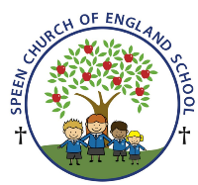Curriculum Overview- Pippins class Spring Term 2026
Week beginning- Monday 16th March ….
Below is some of this week’s learning and highlights…
Literacy
Revision of the Phase 3 GPC’s
Focus on –Oral blending - games and word building/decoding
Tricky words – he me be we was you
Reading decodable short sentences. (We will be writing short phrases modelled and then written independently.)
Reading longer words using the chunking method- ask the children if you are not sure!
Words ending in-ing. Compound words
Mathematics – Building 9 & 10
The children will explore the number 10 and the different ways 10 can be arranged. The children will explore bonds to 10 further and learn that there can be three or more parts, not just two. The children will build on their explorations and findings about doubles to 8, by progressing to doubles to 10.
Spring Term 2 Topic ‘Starry Night’
The Sun
PSHE /RE
To know that Christians believe Jesus performed miracles.
CREATIVE ART & DESIGN
Rockets and Vincent Van Gogh painting–‘ Starry Night ‘
MUSIC- Movement Patterns
The children will work to recognize the structure of a song….To devise a movement sequence….And to perform a song and dance to an audience
GYM Theme: Goldilocks and the Three Bears

To develop rocking and rolling.

